Project #4

Functional Decomposition (“Grainville”)

By Michael Rose

Due: May 10th

Written for: CS475 Spring 2016

Oregon State University

Table of Contents

Code 3

Important Const Variables 3

GrainDeer 3

MyAgent 3

What I did 4

Results 4

2016-2021 4

2016-2116 5

2016-2116 Without Grain 6

2016-2116 Only Populations 7

Table with 6 years of data 8

# Code

## Important Const Variables

const float GRAIN_GROWS_PER_MONTH = 10.0;

const float ONE_DEER_EATS_PER_MONTH = 0.5;

const float ONE_VELOCIRAPTOR_EATS_PER_MONTH = .25;

## GrainDeer

void

GrainDeer() {

while (NowYear <= ENDYEAR) {

int tempNumDeer = NowNumDeer;

tempNumDeer -= (int)((float)NowVelociraptors * ONE_VELOCIRAPTOR_EATS_PER_MONTH);

if (NowNumDeer*ONE_DEER_EATS_PER_MONTH > NowHeight) {

int popDec = (int)((float)NowNumDeer*.05);

if (popDec < 1)

popDec = 1;

tempNumDeer -= popDec;

}

if (NowNumDeer*ONE_DEER_EATS_PER_MONTH < NowHeight) {

int popInc = (int)((float)NowNumDeer*.1);

if (popInc < 1)

popInc = 1;

tempNumDeer += popInc;

}

if (tempNumDeer < 0)

tempNumDeer = 0;

#pragma omp barrier

NowNumDeer = tempNumDeer;

#pragma omp barrier

#pragma omp barrier

}

}

## MyAgent

void

MyAgent() {

while (NowYear <= ENDYEAR) {

int tempVelociraptor = NowVelociraptors;

if (NowVelociraptors*ONE_VELOCIRAPTOR_EATS_PER_MONTH > NowNumDeer)

tempVelociraptor--;

if (NowNumDeer*ONE_VELOCIRAPTOR_EATS_PER_MONTH < NowNumDeer && NowMonth > 5 && NowMonth < 8)

tempVelociraptor++;

if (tempVelociraptor < 0)

tempVelociraptor = 0;

#pragma omp barrier

NowVelociraptors = tempVelociraptor;

#pragma omp barrier

#pragma omp barrier

}

}

# What I did

The main functions for this program, Grain, GrainDeer and MyAgent each control 1 aspect of the simulation. I used the given Grain function, but I did modify the GrainDeer function. I modified how the population increases and decreases. These are based upon the current population, rather than just adding or subtracting 1. The deer population is also dependent on the number of velociraptors because the velociraptors are eating deer.

The velociraptor population grows based upon the quantity of food, but these velociraptors only breed during certain months and therefore the growth period is limited to between the 5th and 8th month.

# Results

## 2016-2021

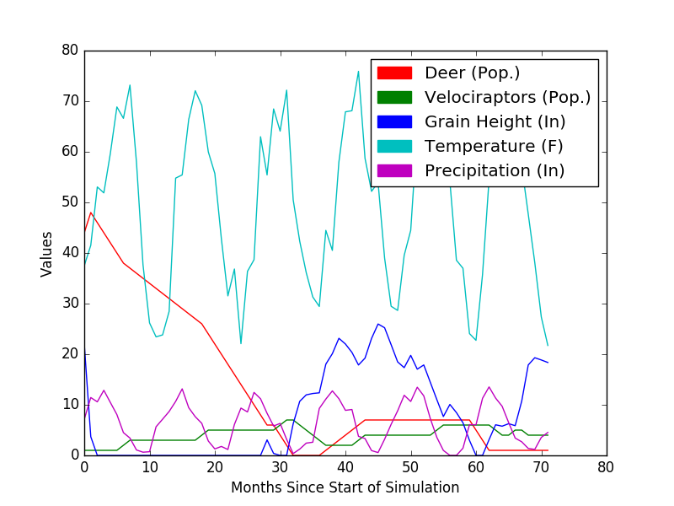

The deer population starts off at 4 and decreases rapidly because of a shortage of food. Around the 30th month, the grain can start to grow. Since the grain starts to grow, by the 36th month, the deer population can return and grow. This growth also allows the velociraptor population to grow after it’s mini-collapse when it ran out of deer to eat.

## 2016-2116

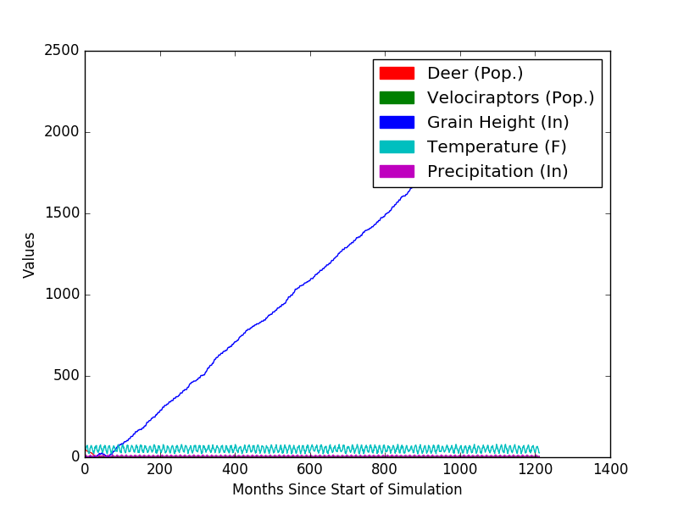

Over the 100 year time span, we can see that the grain height gets out of control. This is unrealistic but the velociraptor population keeps the deer population down so that the grain can grow.

## 2016-2116 Without Grain

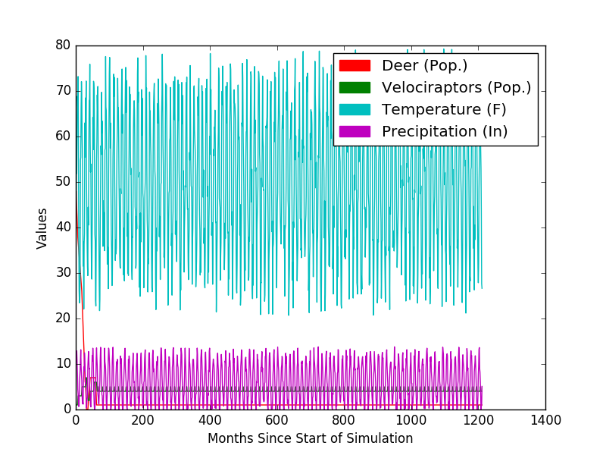

This graph is actualy really hard to read, but we can see that the deer and velociraptor population never grow very large.

## 2016-2116 Only Populations

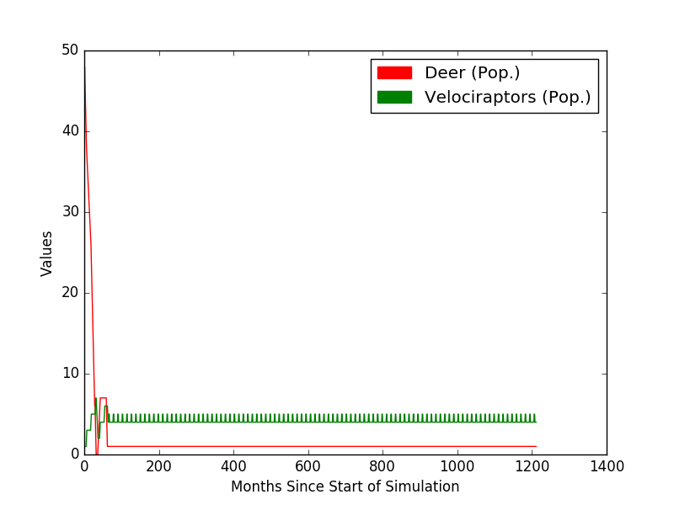

Once we get rid of all the overlapping data, we can see that the velociprator population is greater than the deer population. This is because it is set to have 1 velociraptor eat only .25 deer per month. This allows the velociraptor population be about 4x as high as the deer population.

# Table with 6 years of data

|  |  |  |  |  |  |  |
| --- | --- | --- | --- | --- | --- | --- |
| Month | Year | Deer (Pop.) | Velociraptor (Pop.) | Grain (In) | Temperature (F) | Precipitation (In) |
| 0 | 2016 | 44 | 1 | 22.061871 | 37.485237 | 7.130446 |
| 1 | 2016 | 48 | 1 | 3.687075 | 41.519848 | 11.4364 |
| 2 | 2016 | 46 | 1 | 0 | 53.056568 | 10.58576 |
| 3 | 2016 | 44 | 1 | 0 | 51.880836 | 12.868473 |
| 4 | 2016 | 42 | 1 | 0 | 59.697632 | 10.458521 |
| 5 | 2016 | 40 | 1 | 0 | 68.866463 | 8.068398 |
| 6 | 2016 | 38 | 2 | 0 | 66.614212 | 4.500689 |
| 7 | 2016 | 37 | 3 | 0 | 73.186729 | 3.42214 |
| 8 | 2016 | 36 | 3 | 0 | 57.890614 | 1.073633 |
| 9 | 2016 | 35 | 3 | 0 | 37.65567 | 0.632321 |
| 10 | 2016 | 34 | 3 | 0 | 26.18388 | 0.728906 |
| 11 | 2016 | 33 | 3 | 0 | 23.426113 | 5.663794 |
| 0 | 2017 | 32 | 3 | 0 | 23.815067 | 7.156692 |
| 1 | 2017 | 31 | 3 | 0 | 28.453674 | 8.677876 |
| 2 | 2017 | 30 | 3 | 0 | 54.802109 | 10.668583 |
| 3 | 2017 | 29 | 3 | 0 | 55.435028 | 13.152004 |
| 4 | 2017 | 28 | 3 | 0 | 66.394936 | 9.426767 |
| 5 | 2017 | 27 | 3 | 0 | 72.069565 | 7.650064 |
| 6 | 2017 | 26 | 4 | 0 | 69.190178 | 6.338185 |
| 7 | 2017 | 24 | 5 | 0 | 59.99247 | 2.842791 |
| 8 | 2017 | 22 | 5 | 0 | 55.711281 | 1.2841 |
| 9 | 2017 | 20 | 5 | 0 | 42.828194 | 1.770563 |
| 10 | 2017 | 18 | 5 | 0 | 31.524162 | 1.167192 |
| 11 | 2018 | 16 | 5 | 0 | 36.835976 | 6.123193 |
| 0 | 2018 | 14 | 5 | 0 | 22.07659 | 9.350223 |
| 1 | 2018 | 12 | 5 | 0 | 36.377769 | 8.586864 |
| 2 | 2018 | 10 | 5 | 0 | 38.667896 | 12.448462 |
| 3 | 2018 | 8 | 5 | 0 | 62.981033 | 11.191127 |
| 4 | 2018 | 6 | 5 | 3.058745 | 55.42556 | 8.322733 |
| 5 | 2018 | 6 | 5 | 0.388255 | 68.472557 | 5.805298 |
| 6 | 2018 | 4 | 6 | 0 | 64.084122 | 6.329622 |
| 7 | 2018 | 2 | 7 | 0 | 72.186295 | 3.161039 |
| 8 | 2018 | 0 | 7 | 6.259307 | 50.509697 | 0.363486 |
| 9 | 2018 | 0 | 6 | 10.687067 | 42.327759 | 1.24544 |
| 10 | 2018 | 0 | 5 | 11.965064 | 36.108574 | 2.428254 |
| 11 | 2018 | 0 | 4 | 12.236362 | 31.31361 | 2.604208 |
| 0 | 2019 | 0 | 3 | 12.367105 | 29.434237 | 9.280254 |
| 1 | 2019 | 1 | 2 | 18.032745 | 44.47406 | 11.12645 |
| 2 | 2019 | 2 | 2 | 20.108913 | 40.509487 | 12.749693 |
| 3 | 2019 | 3 | 2 | 23.143093 | 57.975956 | 11.21175 |
| 4 | 2019 | 4 | 2 | 22.016247 | 67.899361 | 8.906537 |
| 5 | 2019 | 5 | 2 | 20.357399 | 68.120613 | 9.073215 |
| 6 | 2019 | 6 | 3 | 17.868999 | 75.902542 | 3.768434 |
| 7 | 2019 | 7 | 4 | 19.221262 | 58.7215 | 3.330849 |
| 8 | 2019 | 7 | 4 | 23.110268 | 52.183582 | 0.951124 |
| 9 | 2019 | 7 | 4 | 25.971869 | 53.952984 | 0.559006 |
| 10 | 2019 | 7 | 4 | 25.230152 | 39.003948 | 3.192064 |
| 11 | 2019 | 7 | 4 | 21.878036 | 29.472679 | 6.142966 |
| 0 | 2020 | 7 | 4 | 18.474884 | 28.650217 | 8.811981 |
| 1 | 2020 | 7 | 4 | 17.343781 | 39.542236 | 11.886529 |
| 2 | 2020 | 7 | 4 | 19.774269 | 44.473434 | 10.658855 |
| 3 | 2020 | 7 | 4 | 17.039591 | 64.181427 | 13.476068 |
| 4 | 2020 | 7 | 4 | 17.873964 | 57.095337 | 11.76689 |
| 5 | 2020 | 7 | 4 | 14.447083 | 72.140129 | 7.280728 |
| 6 | 2020 | 7 | 5 | 11.031681 | 71.710449 | 3.571323 |
| 7 | 2020 | 7 | 6 | 7.682186 | 69.862175 | 0.987191 |
| 8 | 2020 | 7 | 6 | 10.071173 | 54.11705 | 0 |
| 9 | 2020 | 7 | 6 | 8.462191 | 38.574284 | 0 |
| 10 | 2020 | 7 | 6 | 6.453539 | 36.986744 | 1.423364 |
| 11 | 2020 | 7 | 6 | 2.965582 | 24.073624 | 6.074303 |
| 0 | 2021 | 5 | 6 | 0 | 22.744907 | 6.057216 |
| 1 | 2021 | 3 | 6 | 0 | 35.766747 | 11.284541 |
| 2 | 2021 | 1 | 6 | 3.120738 | 54.518654 | 13.535571 |
| 3 | 2021 | 1 | 5 | 6.05137 | 58.86528 | 11.328308 |
| 4 | 2021 | 1 | 4 | 5.774934 | 69.13755 | 9.717295 |
| 5 | 2021 | 1 | 4 | 6.264327 | 65.201729 | 6.481961 |
| 6 | 2021 | 1 | 5 | 5.877684 | 71.008286 | 3.424736 |
| 7 | 2021 | 1 | 5 | 10.720779 | 57.18993 | 2.685954 |
| 8 | 2021 | 1 | 4 | 17.87636 | 47.685879 | 1.378326 |
| 9 | 2021 | 1 | 4 | 19.303358 | 38.105659 | 1.184731 |
| 10 | 2021 | 1 | 4 | 18.859047 | 27.348465 | 3.557775 |
| 11 | 2021 | 1 | 4 | 18.36236 | 21.732067 | 4.53334 |